Snip of Multiple year stock data for the year 2016:

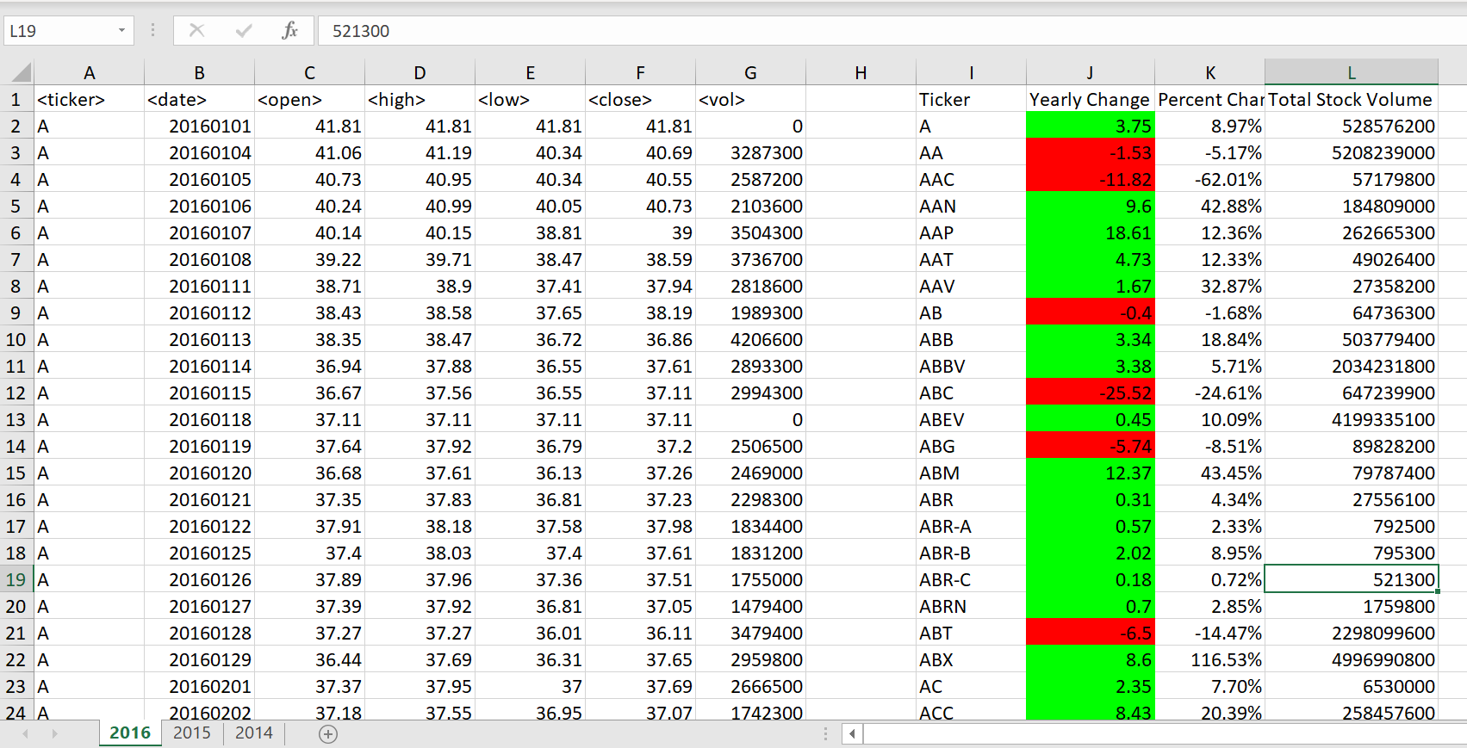

Snip of Multiple year stock data for the year 2015:

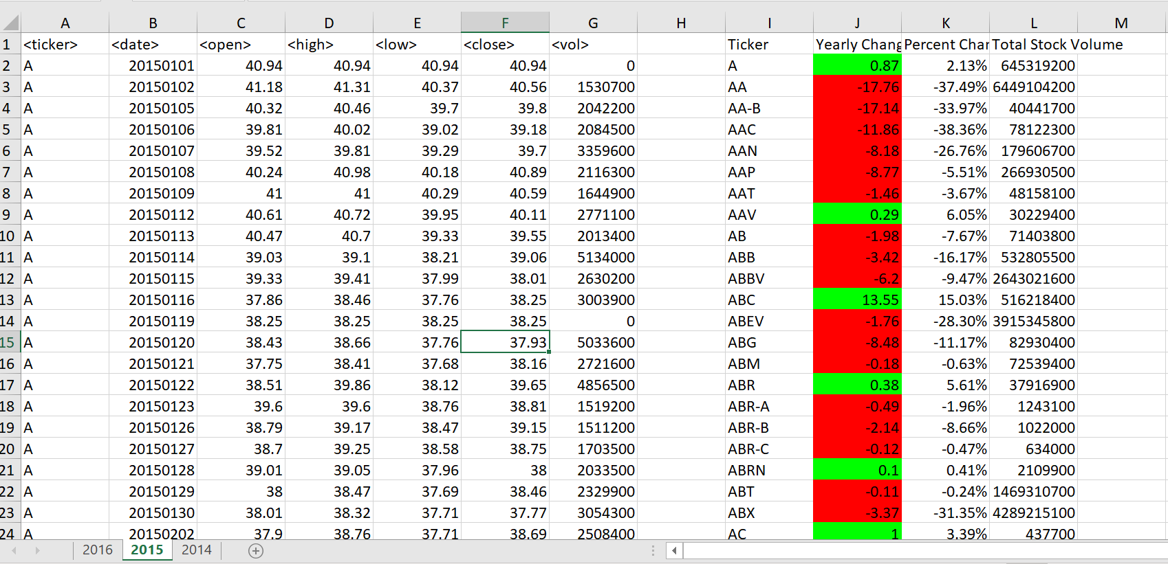

Snip of Multiple year stock data for the year 2014:

